

**SESI 2020/2021 SEMESTER 1**

**SCSV3213 – SECTION 2**

**FUNDAMENTAL OF IMAGE PROCESSING**

**Lecturer: Dr. Md. Sah bin Hj. Salam**

**ASSIGNMENT 2**

**Image Enhancement in Spatial Domain**

**Team members:**

**Simon Chong Kai Yuen (A19EC3028)**

**Clive Lai Yi Cheng (A19EC3019)**

**Ng Shu Yu (A19EC3031)**

**Code:**

classdef Simon_app < matlab.apps.AppBase

% Properties that correspond to app components

properties (Access = public)

UIFigure matlab.ui.Figure

Image matlab.ui.control.Image

ClickthephotobelowtochooseanewimagefromyourcomputerLabel matlab.ui.control.Label

ClicktoselectimageButton matlab.ui.control.Button

developedbySimonChongKaiYuenCliveLaiYiChengNgShuYuLabel matlab.ui.control.Label

Label matlab.ui.control.Label

end

methods (Access = private)

function updateimage(~,PickedImage)

A=imread(PickedImage); %imread() is reads image from local folder

avg = ones(60) /30^2; %creats a 60x60 matrix with value 0.0011 to blur the image

A_adj = imdivide(A,15); %imdivide() is creates a darker pixel

counter = 0;

c_bw = 0;

prompt = 'How many area you want to select? ';

input = inputdlg(prompt, 'Enter a value' , 1, {num2str(3)});

while counter < str2double(input)

bw = im2uint8(roipoly(A)); %im2uint8() is converts the grayscale, RGB, or binary image I to uint8, rescaling or offsetting the data as necessary.

%roipoly() is creates an interactive polygon tool associated with the image displayed in the current figure.

counter = counter + 1 ;

c_bw = bitor(c_bw, bw);

end

bw_cmp = bitcmp(c_bw); %returns the bit-wise complement of bw

roi = bitor(A_adj, bw_cmp); %returns the bit-wise OR of _adj & bw_cmp, cutted image

not_roi = bitor(A, c_bw); %remaining of cut image

filtered = imfilter(roi, avg, 'conv'); %imfilter() uses convolution to blur the selected area

new_img = bitand(not_roi, filtered); %display the image by layers into a single image

imshow(new_img); %display the result

promptMessage = sprintf('Sucessfully! Do you want to save?');

button = questdlg(promptMessage, 'Processed Result', 'No', 'Yes', 'Yes');

if strcmpi(button, 'Yes')

imsave();

end

end

end

% Callbacks that handle component events

methods (Access = private)

% Image clicked function: Image

function ImageClicked(app, event)

end

% Button pushed function: ClicktoselectimageButton

function ClicktoselectimageButtonPushed(app, event)

% Display uigetfile dialog

filterspec = {'*.jpg;*.tif;*.png;*.gif;*.jpeg','All Image Files'};

[f, p] = uigetfile(filterspec);

% Make sure user didn't cancel uigetfile dialog

if (ischar(p))

fname = [p f];

updateimage(app, fname);

end

end

end

% Component initialization

methods (Access = private)

% Create UIFigure and components

function createComponents(app)

% Create UIFigure and hide until all components are created

app.UIFigure = uifigure('Visible', 'off');

app.UIFigure.Position = [100 100 1273 718];

app.UIFigure.Name = 'UI Figure';

% Create Image

app.Image = uiimage(app.UIFigure);

app.Image.ImageClickedFcn = createCallbackFcn(app, @ImageClicked, true);

app.Image.Position = [-73 1 1416 718];

app.Image.ImageSource = 'dawn.jpg';

% Create ClickthephotobelowtochooseanewimagefromyourcomputerLabel

app.ClickthephotobelowtochooseanewimagefromyourcomputerLabel = uilabel(app.UIFigure);

app.ClickthephotobelowtochooseanewimagefromyourcomputerLabel.FontSize = 20;

app.ClickthephotobelowtochooseanewimagefromyourcomputerLabel.FontWeight = 'bold';

app.ClickthephotobelowtochooseanewimagefromyourcomputerLabel.FontColor = [1 1 1];

app.ClickthephotobelowtochooseanewimagefromyourcomputerLabel.Position = [20 22 573 25];

app.ClickthephotobelowtochooseanewimagefromyourcomputerLabel.Text = 'Click the photo to select a new image from your computer.';

% Create ClicktoselectimageButton

app.ClicktoselectimageButton = uibutton(app.UIFigure, 'push');

app.ClicktoselectimageButton.ButtonPushedFcn = createCallbackFcn(app, @ClicktoselectimageButtonPushed, true);

app.ClicktoselectimageButton.Icon = 'IMG_20200814_200954-01-01.jpeg';

app.ClicktoselectimageButton.IconAlignment = 'top';

app.ClicktoselectimageButton.BackgroundColor = [0.651 0.651 0.651];

app.ClicktoselectimageButton.FontWeight = 'bold';

app.ClicktoselectimageButton.FontColor = [0 0 1];

app.ClicktoselectimageButton.Position = [39 71 119 183];

app.ClicktoselectimageButton.Text = {'Click to '; 'select image'};

% Create developedbySimonChongKaiYuenCliveLaiYiChengNgShuYuLabel

app.developedbySimonChongKaiYuenCliveLaiYiChengNgShuYuLabel = uilabel(app.UIFigure);

app.developedbySimonChongKaiYuenCliveLaiYiChengNgShuYuLabel.FontName = 'Ink Free';

app.developedbySimonChongKaiYuenCliveLaiYiChengNgShuYuLabel.FontSize = 30;

app.developedbySimonChongKaiYuenCliveLaiYiChengNgShuYuLabel.FontWeight = 'bold';

app.developedbySimonChongKaiYuenCliveLaiYiChengNgShuYuLabel.Position = [546 505 290 190];

app.developedbySimonChongKaiYuenCliveLaiYiChengNgShuYuLabel.Text = {'developed by:'; ''; 'Simon Chong Kai Yuen'; 'Clive Lai Yi Cheng'; 'Ng Shu Yu'};

% Create Label

app.Label = uilabel(app.UIFigure);

app.Label.FontName = 'Giddyup Std';

app.Label.FontSize = 40;

app.Label.FontColor = [1 1 1];

app.Label.Position = [702 1 1140 123];

app.Label.Text = {'Welcome to our app, you can select any image to '; 'dark and blur it by drwing a freedom shape'};

% Show the figure after all components are created

app.UIFigure.Visible = 'on';

end

end

% App creation and deletion

methods (Access = public)

% Construct app

function app = Simon_app

% Create UIFigure and components

createComponents(app)

% Register the app with App Designer

registerApp(app, app.UIFigure)

if nargout == 0

clear app

end

end

% Code that executes before app deletion

function delete(app)

% Delete UIFigure when app is deleted

delete(app.UIFigure)

end

end

end

**Flow Chart in showing the process in achieving the task and its description.**

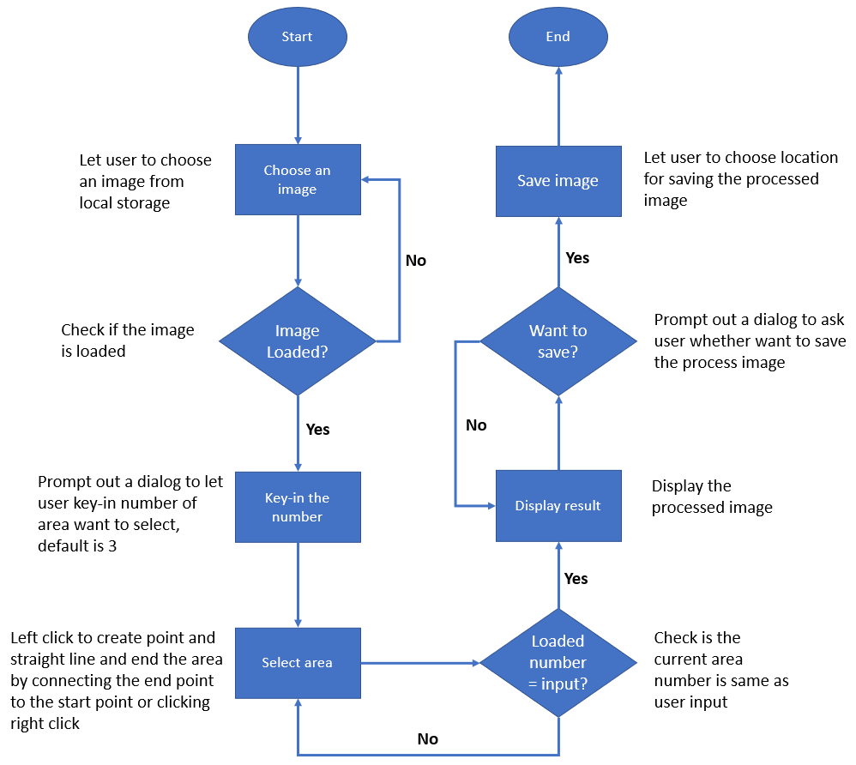

**Example of the image and output.**

All the background image, icon picture at bottom left and the demonstration input image are taken/designed/illustrated/drawn by Simon

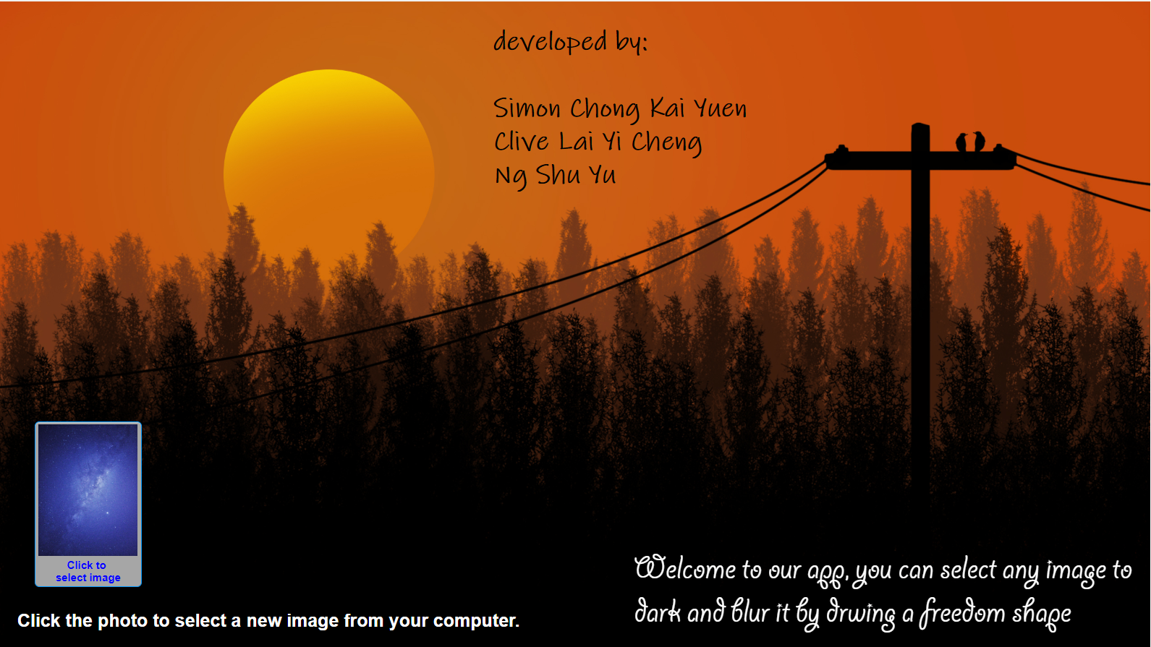

1

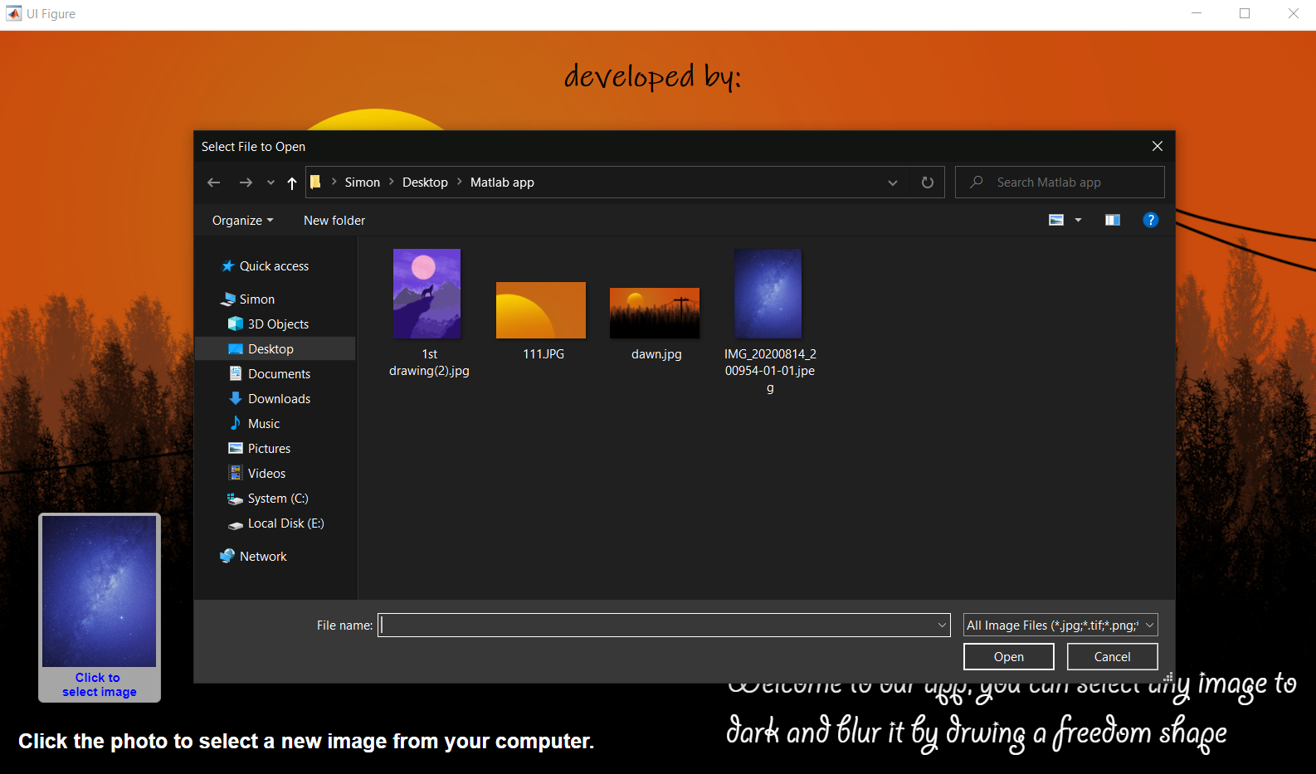

2

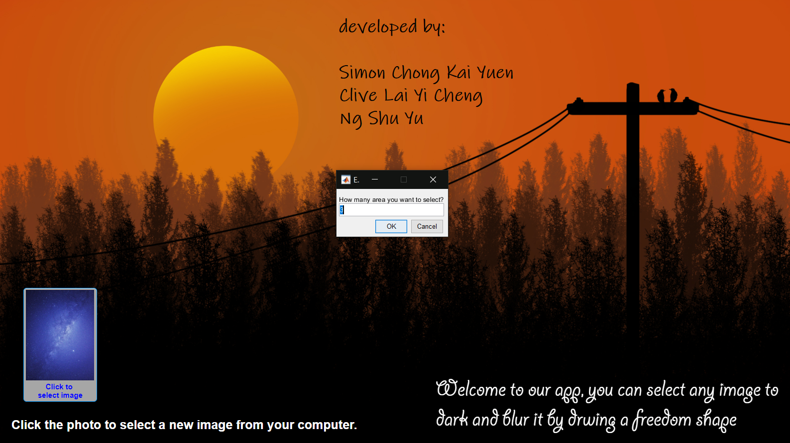

3

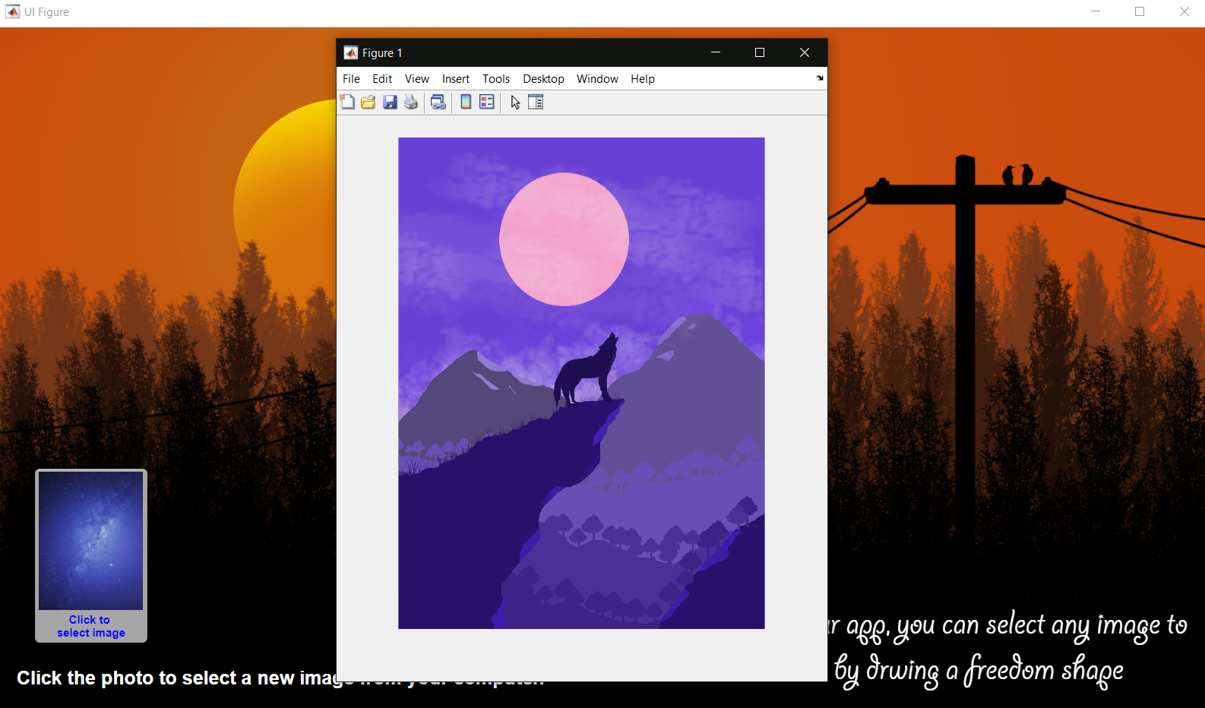

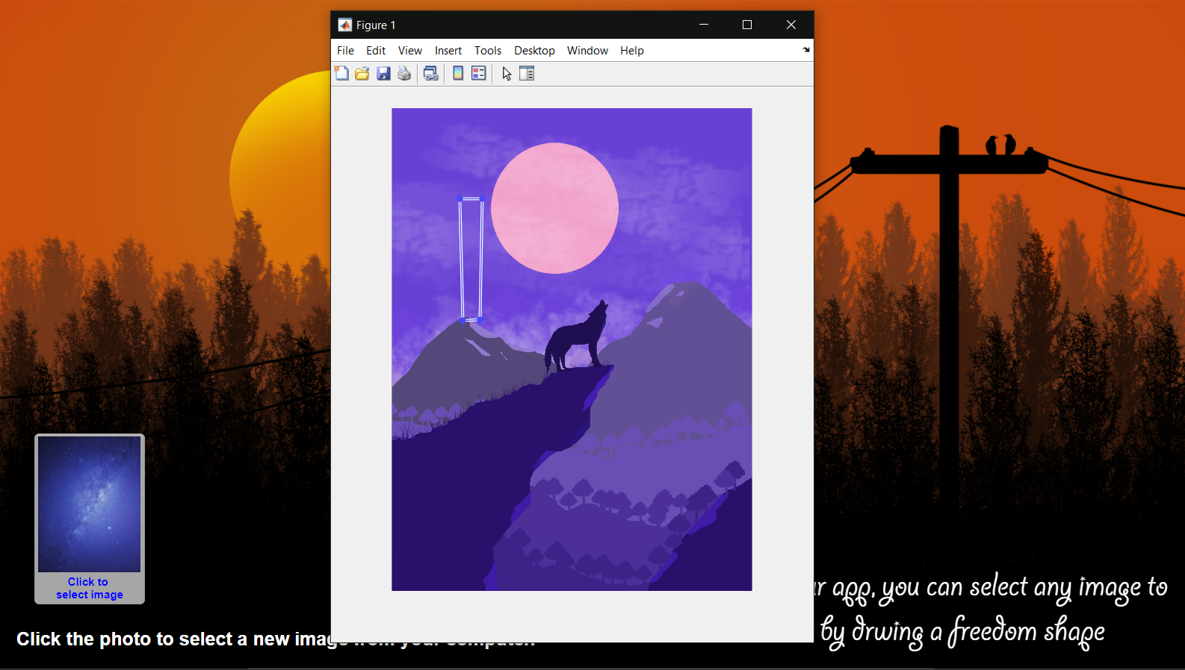 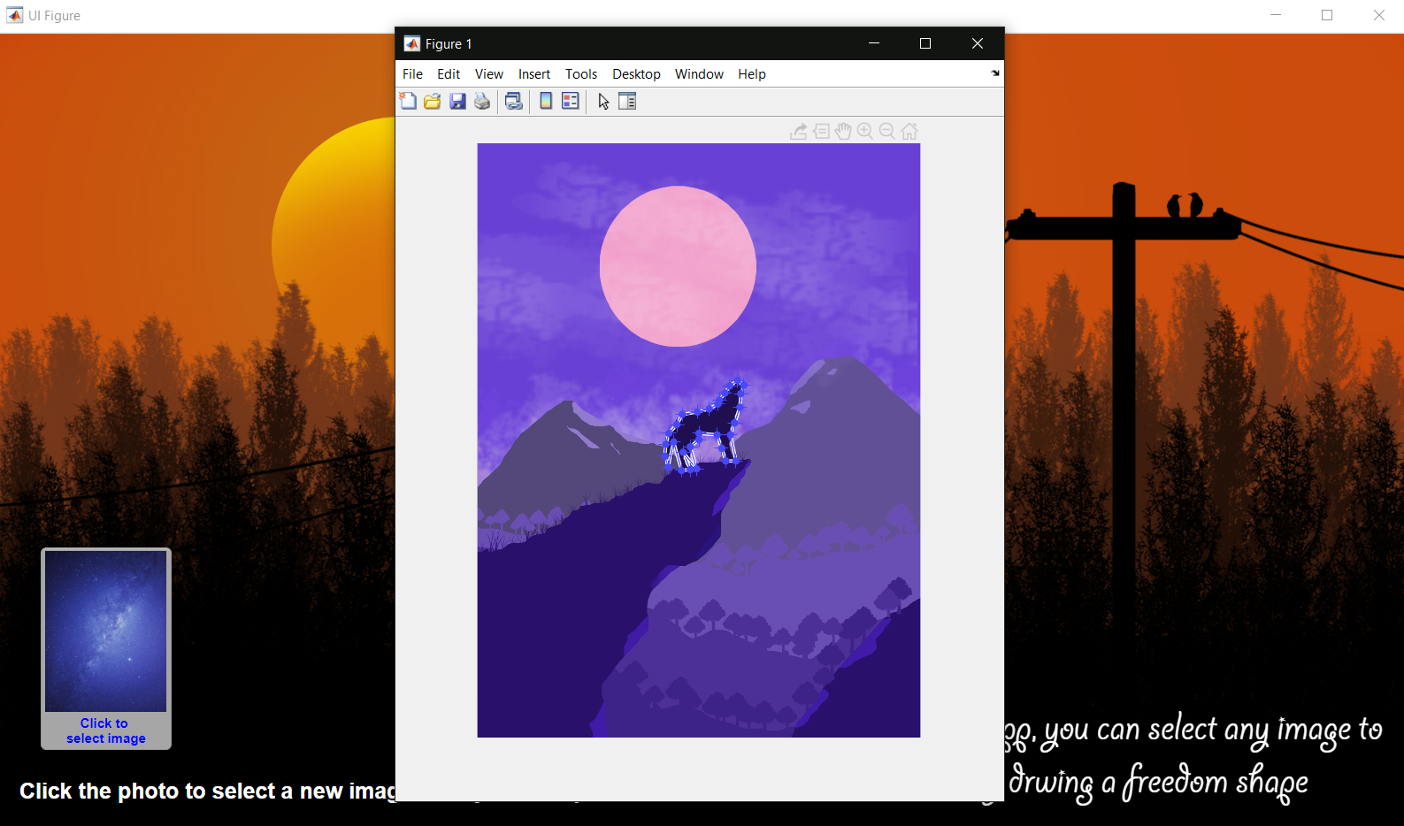 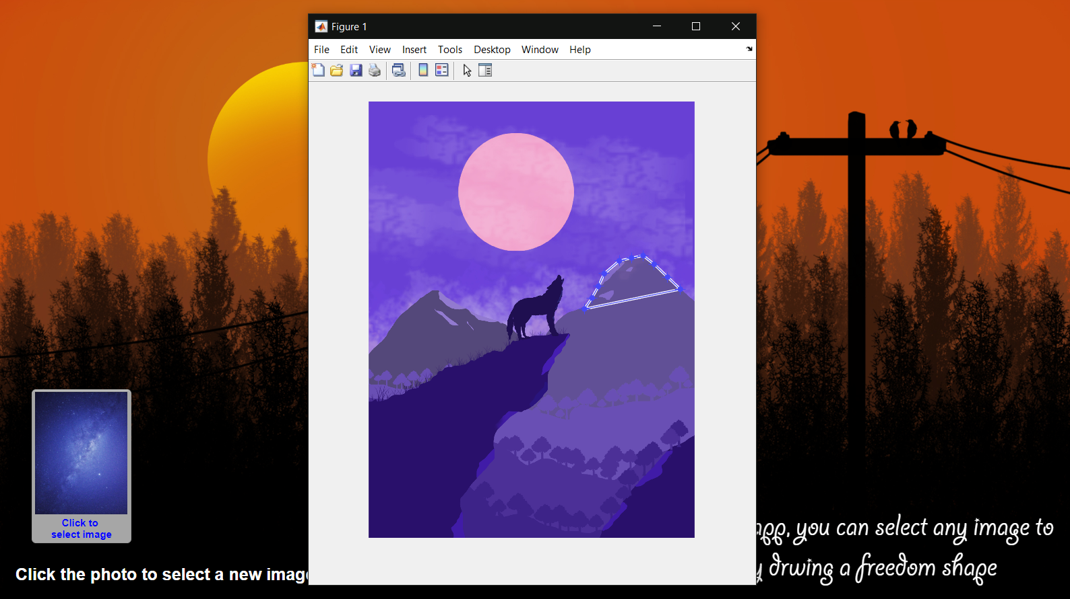

5

4

6

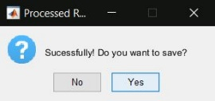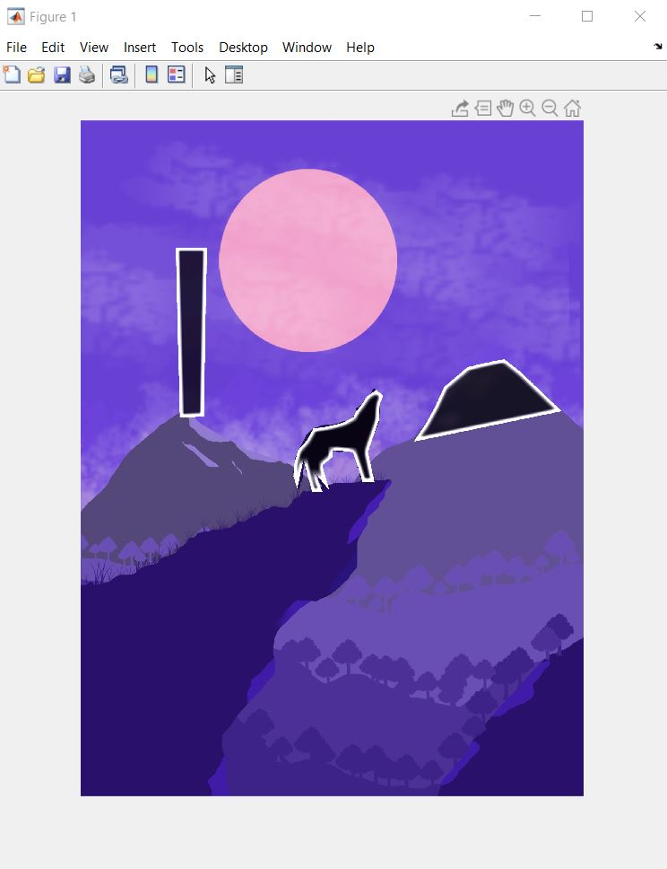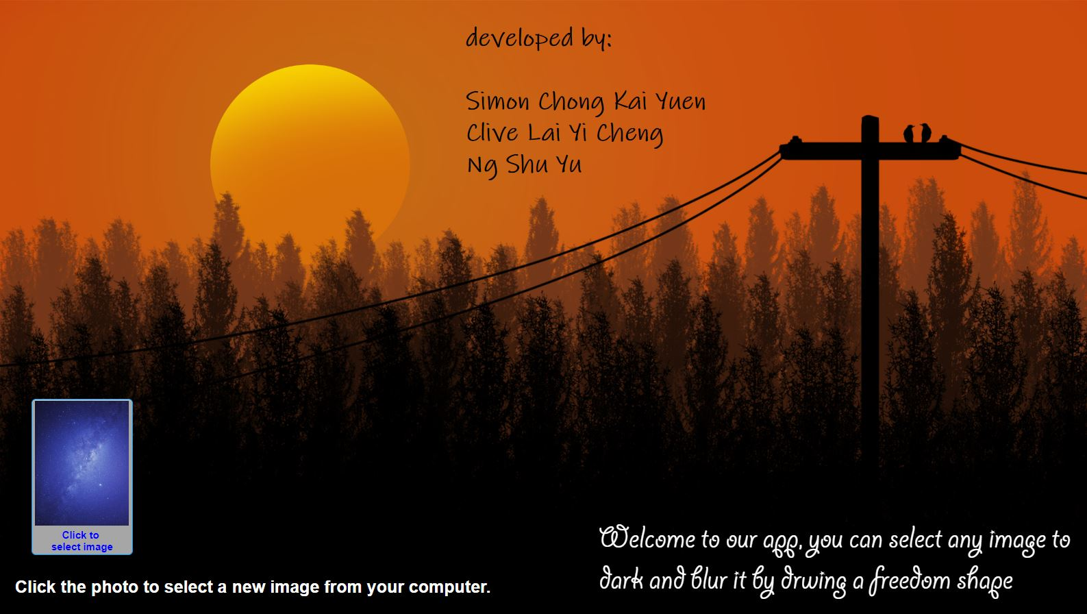

8

7

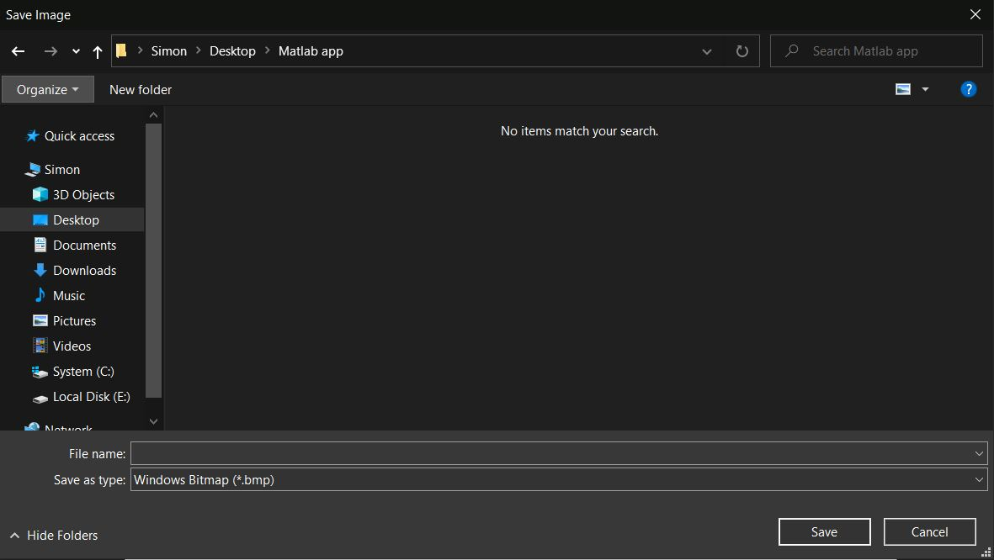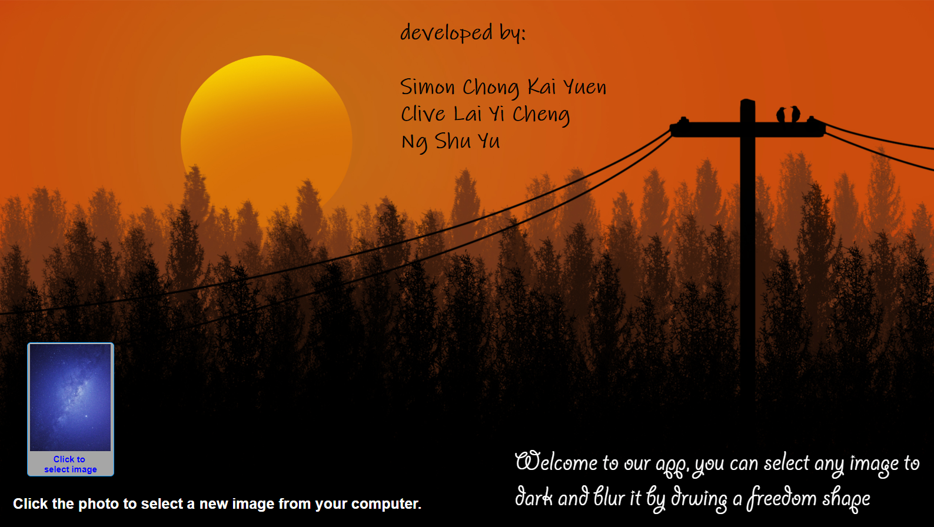

10

9

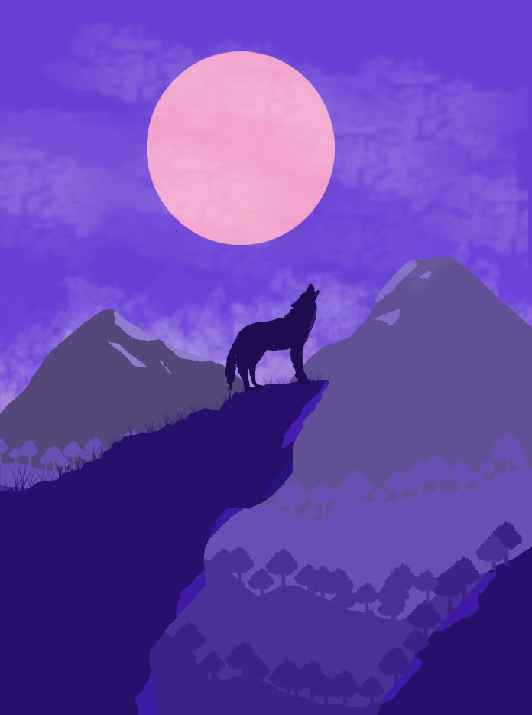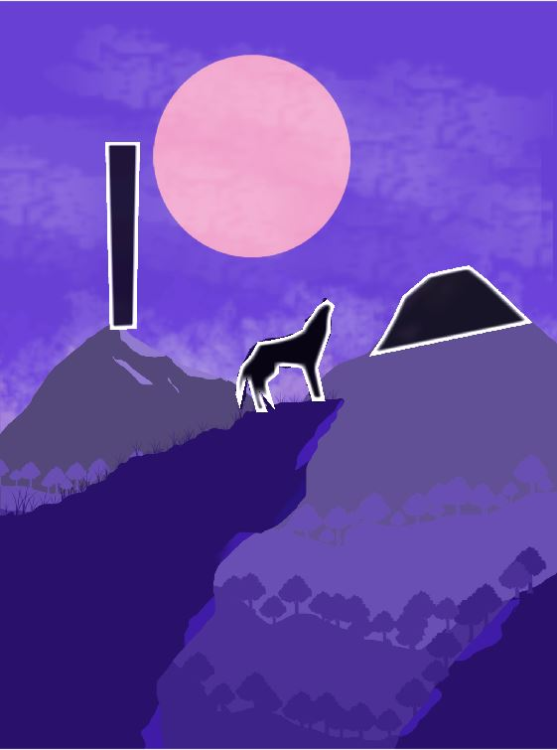

Output

Input